JVM Memory Management

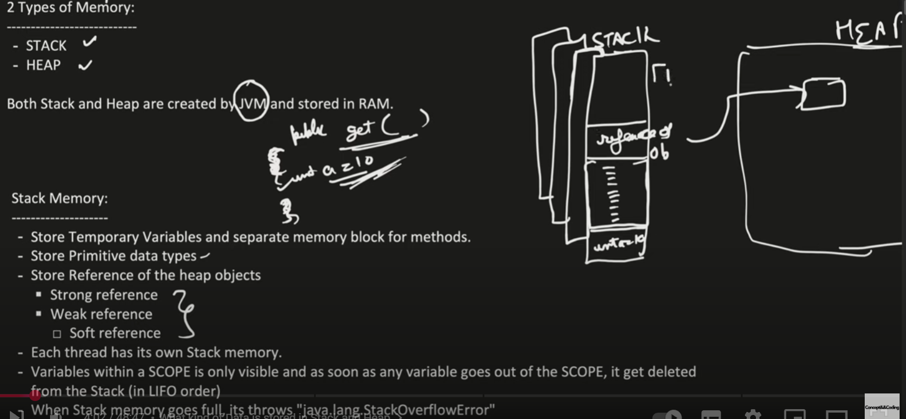

GC Marks o1, o2 to be mark & sweep algo – to be deleted

Minor GC, wil move 01, 03, 04 and put into S1 and o2, o5 removed on GC

Obj 5 and obj 4 marked for deletion

Threshold 3, obj 8 and obj9 creted – 3rd time GC runs